Question 22:
Store five mobile brands and their top model. Use if-else to check if a certain brand exists.
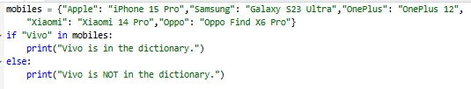
Output:
